Mental Health First Aid For

Montgomery County’s Faith Community

Mental Health Association of Montgomery County is holding a Mental Health First Aid training for Montgomery County’s faith community. This training is for faith leaders and congregation members at local churches, synagogues, temples and other places of worship. The training is **free of charge** thanks to support from the Montgomery County Government.

1 in 4 people deal with a mental health issue each year. Are you prepared to help a member of your congregation who you suspect is dealing with a mental health crisis? If you thought someone was depressed, what would you say to reach out? Mental Health First Aid can assist you in feeling prepared to reach out to someone dealing with a mental health issue.

Mental Health First Aid is designed to teach community members how to help a friend, family member, co-worker or acquaintance who is experiencing a mental health or addictions challenge or is in crisis. The course introduces common mental health challenges, reviews typical behavior for someone dealing with a mental health crisis and teaches a 5-step action plan for how to help people in both crisis and non-crisis situations. Topics covered include anxiety, depression, substance use, disorders in which psychosis may occur and eating disorders.

**When:** Saturday, March 7th, 8:30 am – 5:00 pm

**Where:** Mental Health Association (Conference Room)

1000 Twinbrook Parkway, Rockville, MD 20851

***Space is VERY limited, so please register early.***

*Lunch will be served.*

A completed registration form is required for each participant. Return completed registration forms to Jasmine Berry at [jberry@mhamc.org](mailto:jberry@mhamc.org).

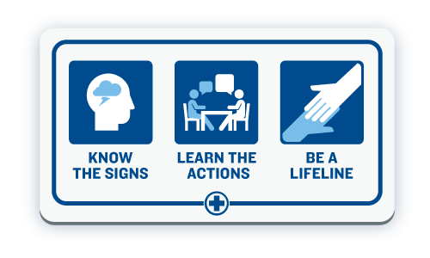Name _______________________________________________

Affiliation _____________________________________________

Phone _______________________________________________

E-mail ________________________________________________