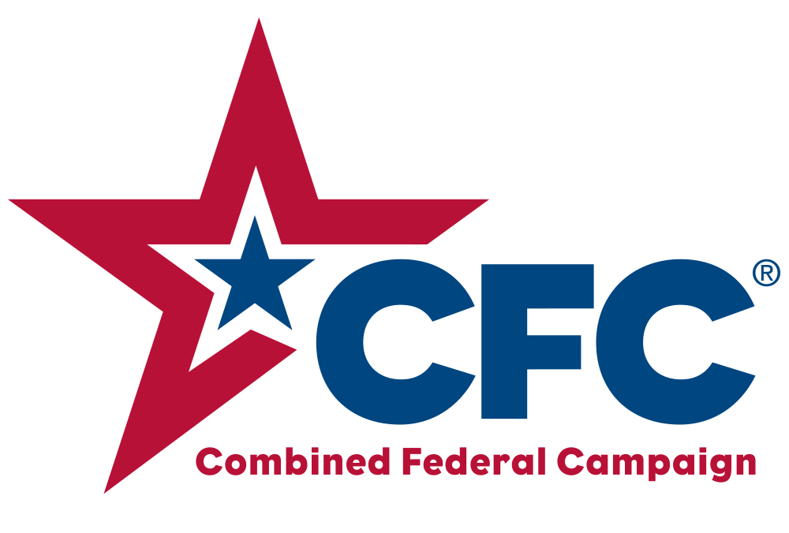
This year once again Unitarian Universalists for Social Justice is taking part in the Combined Federal Campaign of the National Capital Area. To donate to the work of UUSJ in encouraging and promoting collective regional UU action for social justice and to amplify our voice with public policy makers choose 17271 on your Combined Federal Campaign form.

This year once again Unitarian Universalists for Social Justice is taking part in the Combined Federal Campaign of the National Capital Area. To donate to the work of UUSJ in encouraging and promoting collective regional UU action for social justice and to amplify our voice with public policy makers choose 17271 on your Combined Federal Campaign form.

This year once again Unitarian Universalists for Social Justice is taking part in the Combined Federal Campaign of the National Capital Area. To donate to the work of UUSJ in encouraging and promoting collective regional UU action for social justice and to amplify our voice with public policy makers choose 17271 on your Combined Federal Campaign form.

This year once again Unitarian Universalists for Social Justice is taking part in the Combined Federal Campaign of the National Capital Area. To donate to the work of UUSJ in encouraging and promoting collective regional UU action for social justice and to amplify our voice with public policy makers choose 17271 on your Combined Federal Campaign form.

This year once again Unitarian Universalists for Social Justice is taking part in the Combined Federal Campaign of the National Capital Area. To donate to the work of UUSJ in encouraging and promoting collective regional UU action for social justice and to amplify our voice with public policy makers choose 17271 on your Combined Federal Campaign form.

This year once again Unitarian Universalists for Social Justice is taking part in the Combined Federal Campaign of the National Capital Area. To donate to the work of UUSJ in encouraging and promoting collective regional UU action for social justice and to amplify our voice with public policy makers choose 17271 on your Combined Federal Campaign form.

This year once again Unitarian Universalists for Social Justice is taking part in the Combined Federal Campaign of the National Capital Area. To donate to the work of UUSJ in encouraging and promoting collective regional UU action for social justice and to amplify our voice with public policy makers choose 17271 on your Combined Federal Campaign form.

