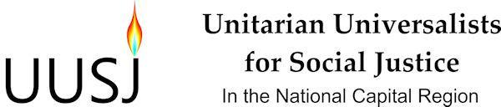

Draft Board Meeting Agenda for October 4, 2014
Accotink Unitarian Universalist Church

5:30 or immediately following the afternoon program, we will gather for a brown bag dinner (please bring your own; our hosts will provide beverages and dessert).

5:45 pm Welcome, Chalice Lighting, Reading

6:00 pm Call Meeting to Order, Introduction of Board Members and Visitors, and Review of the Agenda

Quorum Count, Approval of May 10, 2014 Minutes and Qs & As on June 22, 2014 Special Meeting Notes - Bill Alsmeyer-Johnson, Secretary

Treasurer's Report - John Gubbings, Treasurer

Program Committee: Debriefing on the afternoon program and lessons learned. Preview of tentative events and programs for the year.

Core Group Report/Discussion/General Update on Activities: Report on progress since June 22 meeting including discussion of grant application to the UU Fund Program, upcoming special Board meeting on governance, and strategic communications and media plans.

Communications and Outreach Committee Discussion

Discussion of Board Member and Congregational Responsibilities to UUSJ. Please refer to the handout" “Responsibilities of Member Congregations, Roles and Responsibilities of Board Members.”

Announcements

8 pm Closing Words and Adjournment

