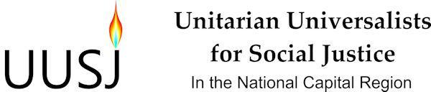

Draft Board Meeting Agenda for October 4, 2014
Accotink Unitarian Universalist Church

5:30 or immediately following the afternoon program, we will gather for a brown bag dinner (please bring your own; our hosts will provide beverages and dessert).

5:45 pm Welcome, Chalice Lighting, Reading

6:00 pm Call Meeting to Order, Introduction of Board Members and Visitors, and Review of the Agenda

Quorum Count, Approval of May 10, 2014 Minutes and Qs & As on June 22, 2014 Special Meeting Notes - Bill Alsmeyer-Johnson, Secretary

Treasurer's Report - John Gubbings, Treasurer

Program Committee: Debriefing on the afternoon program and lessons learned. Preview of tentative events and programs for the year.

Core Group Report/Discussion/General Update on Activities: Report on progress since June 22 meeting including discussion of grant application to the UU Fund Program, upcoming special Board meeting on governance, and strategic communications and media plans.

Orientation: Discussion of Board Member and Congregational Responsibilities to UUSJ. Please refer to the handout "Responsibilities of Congregations.

Announcements

8 pm Closing Words and Adjournment

