An Interfaith, Multicultural Celebration of Dr. King’s Birthday
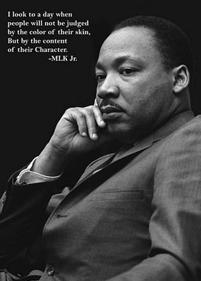

Sunday, January 19, 2014, 3 PM
Cedar Lane Unitarian Universalist Church
9601 Cedar Lane, Bethesda MD 20814
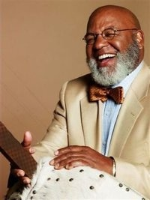
Featuring
Fred Johnson, Director of Strategic Initiatives, Intersections International, New York & internationally renowned jazz musician;
Local Religious Leaders and Musical Groups; & Rev. Abhi Janamanchi.

The program will feature a multicultural musical ensemble, excerpts from the writings of Dr. Martin Luther King and prayers/readings from world religions.

Free Admission
Childcare for infants & toddlers provided
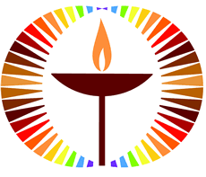
Sponsored by the Cedar Lane “Together” diversity team.
For more information, please call 301-493-8300 or email togetherLT@googlegroups.com.

